Anneka Lenssen

335 words

**Moudarres, Fateh al- (Born near Aleppo, Syria, 1922-died Damascus, Syria, 1999)**

Fateh al-Moudarres is considered a leader among Syria’s generation of modernist painters born in the 1920s. Because of his early participation in literary salons, his freeform and intuitive style of drawing and painting, and his willingness to express contrarian and independent views about culture and authority, al-Moudarres enjoyed widespread respect in the Arab world as an authentically modern artist. Al-Moudarres represented Syria in numerous international exhibitions, including biennials in Venice and São Paulo. A polymath who also wrote poems and short stories and composed for the piano, his career began in the cultural circles of Aleppo in the 1940s, where he experimented with Surrealist modes of composition. He would subsequently hone a semi-naïve style of painting and a repertoire of imagery drawn from the myths of ancient Syrian civilizations, religious icons, the land and its flora, and rural custom. In 1956, he was granted a four-year study fellowship at the Academy of Fine Arts in Rome. Al-Moudarres settled in Damascus after finishing and joined the faculty at the new College of Fine Arts. Always a prolific artist, he painted and taught in Damascus for decades, where he served as a role model and mentor for emerging generations of Syrian artists.

**References and further reading**

Atassi, Mouna, and Samir Sayegh (1998) *Contemporary Art in Syria, 1898-1998*, Damascus: Gallery Atassi. (Contributor’s comment: Most comprehensively illustrated volume on modern Syrian art).

Hamarneh, Samar (1999) *Kayfa yara Fateh Moudarres (Fateh Moudarres's Point of View)*, Damascus: Teyebah Printing. (Contributor’s comment: Monograph on the artist produced by a friend, includes recollections and ephemera from artists’ contemporaries).

Institut du Monde Arabe (1996) *Fateh al-Moudarres*, Paris: Institut du Monde Arabe/Gallery Atassi. (Contributor’s comment: Exhibition catalog from artist’s solo exhibition at the Institut du Monde Arabe. Includes some catalog essays celebrating the artist’s style of work).

Al Sharīf, Tariq (1991) *Fateh al-Moudarres: Fann Hadith…Bi-Ruh Taʿabiriyya (Fateh al-Moudarres: Modern Art…With an Expressive Spirit)*, Damascus: Ministry of Culture. (Contributor’s comment: published by the Syrian government, this is the official account of the artist’s life and work).

**Paratextual material**

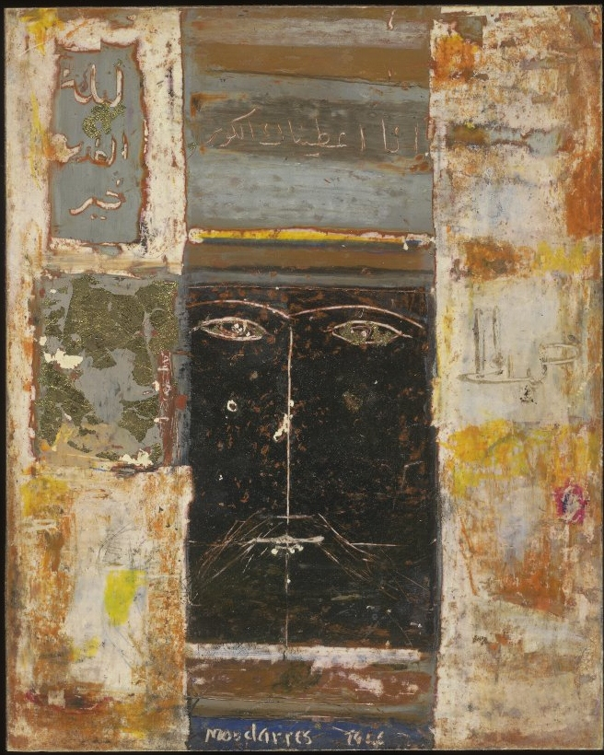

Fateh al-Moudarres, untitled, 1966, oil on wooden panel, 19.5x15.6 cm.

Source and copyright: The British Museum, Museum number 2005,0708,0.1 (Rights will need to be secured through the British Museum)